# FULL SEMESTER INTERNSHIP REPORT

**On**

## “PYTHON AND DATA SCIENCE”

***Submitted in partial fulfillment of the requirements for the award of the degree of***

## BACHELOR OF TECHNOLOGY

***in***

***COMPUTER SCIENCE AND BUSINESS SYSTEMS***

**By**

*KARE BHARATH CHANDRA 219X1A3348*

**

**Department of Emerging Technologies in Computer Science (ECS)**

**G. Pulla Reddy Engineering College (Autonomous): Kurnool-518007, Andhra Pradesh,**

**India**

**(Affiliated to Jawaharlal Nehru Technological University-Anantapur, Ananthapuram) 2021-2025**

# Department of Emerging Technologies in Computer Science (ECS)

**G. Pulla Reddy Engineering College (Autonomous): Kurnool-518007**

**(Affiliated to Jawaharlal Nehru Technological University-Anantapur, Ananthapuram)**



Certificate

This is to certify that an Internship entitled **“PYTHON & DATA SCIENCE”** is a bona-fide work done by **Kare Bharath Chandra (Regd.No: 219X1A3348)** of G. Pulla Reddy Engineering College (Autonomous): Kurnool, Andhra Pradesh, India, for partial fulfillment of the requirements for the award of degree of **Bachelor of Technology** in **Computer Science and Engineering (AI &ML)** during the academic year 2021-2025.

The results embodied in this thesis have not been submitted to any other University or Institute for the award of any degree.

#### Internship Mentor Head of the Department

***Smt. M. Manasa Dr. R. Praveen Sam***

Assistant Professor Professor & HOD

Department of ECS Department of ECS

**An Internship Report**

*Submitted in accordance with the requirement for the degree of B.Tech*

**Name of the College:** G. PULLA REDDY ENGINEERING COLLGE

**Department:** EMERGING TECHNOLOGIES IN COMPUTER SCIENCE (ECS)

**Name of the Faculty Guide:** Smt. M. Manasa

**Duration of the Internship:** 8 Weeks **From:** 06/01/2025 **To:** 18/04/2025

**Name and address of the Organisation:** The Web Blinders, Innovation & Incubation center, GPREC, Andhra Pradesh, 518007, India.

**Name of the Student:** KARE BHARATH CHANDRA

**Programme of Study:** BACHELOR OF TECHNOLOGY **Year of Study:** IV

**Register Number:** 219X1A3348

#### Date of Submission:

I, KARE BHARATH CHANDRA, a student of Computer Science and Engineering (AI & ML) program, Reg. No. **219X1A3348** of the Department of EMERGING TECHNOLOGIES IN COMPUTER SCIENCE, G. PULLA REDDY ENGINEERING College d here by declare that I have completed the mandatory internship from January 06,2025 to April 18,2025 in The Web Blinders under the Faculty Guideship of **Smt. M. Manasa,** Department of EMERGING TECHNOLOGIES IN COMPUTER SCIENCE, G. PULLA REDDY ENGINEERING College (Autonomous), Kurnool.

***(Signature and Date)***

#### Endorsements

Faculty Guide:

Smt. M. Manasa,

Assistant Professor,

Department of ECS.

Head of the Department:

Dr. R. Praveen Sam,

Professor and HOD,

Department of ECS.

Principal:

Dr. B. Sreenivasa Reddy,

Principal,

G. Pulla Reddy Engineering College.

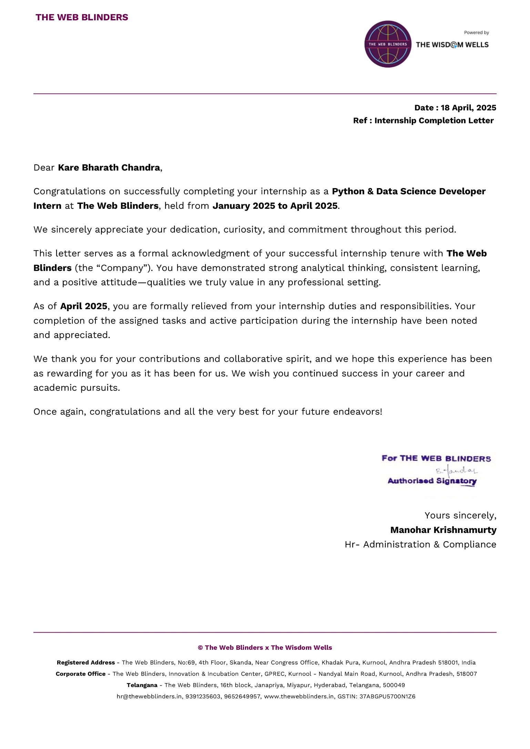

**Acknowledgements**

I would like to take this opportunity to express my deepest and most heartfelt gratitude to the exceptional individuals and resources that played a pivotal role in the successful completion of my internship project at **The Web Blinders.** This journey has been a transformative experience, and I owe a debt of thanks to the following:

I wish to express my deep sense of gratitude to my internship guide **Smt. M. Manasa,** Assistant Professor, of Emerging Technologies in Computer Science Department, G. Pulla Reddy Engineering College, for her immaculate guidance, constant encouragement and cooperation which have made possible to bring out this project work.

I am grateful to my internship incharge **Mr. K. Nagaraju**, Assistant Professor of Emerging Technologies in Computer Science Department, G. Pulla Reddy Engineering College, for helping me and giving me the required information needed for my internship.

I am thankful to my Head of the Department **Dr. R. Praveen Sam**, for his whole hearted support and encouragement.

I am grateful to my respected Principal **Dr. B. Sreenivasa Reddy** for providing requisite facilities and helping me in providing such a good environment. I wish to convey my acknowledgements to all the staff members of the Emerging Technologies in Computer Science department for giving the required information. Finally,

I am equally indebted to my peers and colleagues at **The Web Blinders**. Their willingness to share their own experiences, offer valuable insights, and engage in collaborative efforts greatly enriched my understanding of the intricacies of the projects we undertook. The camaraderie and shared pursuit of excellence were instrumental in the successful outcomes we achieved.

I would like to extend my gratitude to any project sponsors or organizations that believed in the potential of this internship project and provided the necessary support, resources, or funding. Their faith in our vision was instrumental in bringing it to fruition.

Last but certainly not least, my heartfelt appreciation goes out to my family and friends. Their unwavering support, boundless encouragement, and unwavering understanding have been my pillars of strength throughout this intensive learning journey. Their belief in my abilities and their willingness to stand by me during the challenges and triumphs have been the driving force behind my accomplishments.

The successful completion of this internship project stands as a testament to the collective effort, dedication, and collaboration of all those mentioned above. I am deeply appreciative of the contributions made by each individual and resource, and I carry the knowledge and experiences gained during this internship forward with a sense of profound gratitude and humility.

## CHAPTER 1: EXECUTIVE SUMMARY

### LEARNING OBJECTIVES AND OUTCOMES:

* Gained hands-on experience in data science tools and technologies such as Python, Pandas, NumPy, and Scikit-learn.
* Learned the complete data preprocessing pipeline including handling missing values, encoding, and scaling.
* Acquired knowledge in performing Exploratory Data Analysis (EDA) using Matplotlib and Seaborn.
* Understood the fundamentals of machine learning including supervised and unsupervised learning techniques.
* Learned to evaluate models using techniques like cross-validation and accuracy metrics.
* Gained insights into dimensionality reduction techniques like PCA for improving model efficiency.
* Explored advanced topics such as ensemble learning, CNN, RNN, and NLP for real-world applications.
* Developed a EDA analysis project by cleaning and analyzing text data from dataset.
* Learned to use Jupyter Notebook and Anaconda for coding and visualization tasks.
* Documented project progress and participated in review discussions and presentations effectively.

**ACTIVITIES DONE:**

* Data Preprocessing and Exploratory Data Analysis
* Machine Learning Model Training and Evaluation
* EDA Analysis Project Development
* Visualization and Insight Generation using Python Libraries
* Code Documentation and Internship Presentation Preparation

## CHAPTER 2: OVERVIEW OF THE ORGANIZATION

### INTRODUCTION OF THE ORGANIZATION

**The Web Blinders** is a dynamic software company headquartered in Kurnool, Andhra Pradesh. Specializing in the development of enterprise applications, web applications, and mobile apps, the company offers innovative digital solutions tailored to various industries, including real estate, construction, education, and healthcare. With a focus on integrating cutting-edge technologies such as AI and machine learning, The Web Blinders empowers businesses to enhance their digital presence and operational efficiency.

The company's diverse product portfolio includes real estate management software, construction ERP systems, faculty data management tools, fee management solutions, and educational platforms like SkillForge and MediVista. Additionally, The Web Blinders provides comprehensive training and internship programs, fostering skill development in areas like Python and data science.

### VISION, MISSION AND VALUES OF THE ORGANIZATION

**Vision:** To revolutionize industries by delivering intelligent, scalable, and customized digital solutions that empower businesses to operate efficiently and grow exponentially.

**Mission:** To provide innovative and reliable web, mobile, and enterprise application solutions by leveraging modern technologies, while fostering talent through practical training and hands-on learning.

**Values of the Organization:**

* Delivers end-to-end tech solutions that bridge the gap between business goals and technological execution.
* Encourages collaboration between clients, developers, and domain experts to create impactful and user-friendly applications.
* Promotes a learning-driven environment where interns and employees grow through real-time project exposure and mentorship.
* Emphasizes quality, innovation, and timely delivery, ensuring maximum client satisfaction and long-term success.
* Supports skill-building through internship programs in emerging technologies like AI, data science, and web development.

1. **POLICY OF THE ORGANIZATION, IN RELATION WITH THE INTERN ROLE**

As part of commitment to fostering talent and innovation, The Web Blinders internship offers hands-on experience in cutting-edge technologies, mentorship from industry professionals, and opportunities to contribute to meaningful projects that align with our vision of empowering learners and advancing global knowledge to interns.

1. **ORGANIZATIONAL STRUCTURE**

The Web Blinders operates with a streamlined structure that includes dedicated teams for software development, data science, UI/UX design, and business operations. Departments function collaboratively under the guidance of project managers and team leads, ensuring smooth workflow and accountability. Reporting flows from interns and developers to team leads and then to the co-founders, promoting transparency and agile communication.

1. **ROLES AND RESPONSIBILITIES OF THE EMPLOYEES IN WHICH THE INTERN IS PLACED**

In The Web Blinders' Data Science internship, interns assist in data collection, preprocessing, and exploratory data analysis using Python. They work closely with data analysts and developers to clean datasets, visualize trends, and support model-building activities. Interns also participate in team meetings and learn practical skills under the guidance of experienced mentors.

1. **PERFORMANCE OF THE ORGANIZATION**

The Web Blinders consistently delivers reliable and innovative tech solutions, earning trust through quality work, client satisfaction, and practical use of emerging technologies.

1. **FUTURE PLANS OF THE ORGANIZATION**

The organization plans to expand into advanced AI-driven applications and strengthen its internship programs by offering more hands-on industry projects and academic collaborations.

**CHAPTER 3: INTERNSHIP PART**

During the internship at The Web Blinders, interns worked in a collaborative and learning-oriented environment focused on real-time data science applications. The internship followed a hybrid mode with both online and offline interactions, offering access to essential tools like Jupyter Notebook, Anaconda, and cloud resources. Interns engaged in daily tasks during standard working hours, typically 8 hours per day, 5 days a week. Equipped with laptops and necessary software environments, interns actively participated in Python-based data analysis tasks, regular review sessions, and project development meetings.

**Tasks Performed By Interns:**

* Performed data preprocessing including handling missing values, outlier detection, and feature engineering.
* Conducted exploratory data analysis (EDA) to understand trends, patterns, and correlations in the dataset.
* Assisted in model selection and evaluation using logistic regression and other ML algorithms.
* Participated in the development of a sentiment analysis project using real-world customer feedback data.
* Attended review sessions, contributed to team discussions, and documented progress regularly.

#### Skills Developed:

* Gained proficiency in Python and data science libraries like Pandas, NumPy, Matplotlib, and Scikit-learn.
* Improved analytical and problem-solving skills through hands-on data processing and modeling tasks.
* Strengthened collaboration and teamwork through active participation in group tasks and presentations.
* Enhanced communication skills via daily stand-ups, peer interaction, and mentor reviews.
* Learned time and task management by balancing assignments, project work, and reporting timelines.

### ACTIVITY LOG FOR THE FIRST WEEK

|  |  |  |  |
| --- | --- | --- | --- |
| **Day & Date** | **Brief description of the daily activity** | **Learning Outcome** | **Person In-Charge**  **Signature** |
| 06/01/2025 | Attended online orientation session introducing the company and internship. | Gained an overview of Web blinders, its mission, structure, and internship expectations. |  |
| 07/01/2025 | Learned about internship workflow, task flow, and evaluation process. | Understood project lifecycle, task allocation, and performance assessment methods. |  |
| 08/01/2025 | Introduction to tools: Zoom, Slack, Trello, and Google Workspace. | Learned to navigate communication and project management platforms |  |
| 16/01/2025 | Session on upcoming topics: Python, data preprocessing, EDA. | Acquired clarity on technical topics and roadmap to be covered in future weeks. |  |
| 17/01/2025 | Interaction with mentors and fellow interns. | Understood team dynamics, communication etiquette, and importance of collaboration. |  |
| 18/01/2025 | Recap of orientation; Q&A session for clarifying doubts. | Strengthened understanding of workflow, resolved queries, and prepared for technical learning ahead. |  |

**WEEKLY REPORT**

**WEEK – 1 (From Dt 06/01/2025 to Dt 18/01/2025)**

**Objective of the Activity Done:** To gain an in-depth understanding of the company’s structure, internship workflow, tools for collaboration, and upcoming learning modules, laying a strong foundation for the technical journey ahead.

**Detailed Report:** The first week of my internship at Web blinders was entirely focused on orientation sessions, conducted online as part of the hybrid model. These sessions provided a detailed introduction to the company, its structure, and the overall internship workflow. The mentors explained the expectations, task assignments, reporting procedures, and how projects would be carried out in the later stages. Additionally, I was introduced to the essential tools for communication and collaboration, including video conferencing platforms, messaging apps, and project management software, which would be used throughout the internship.

Apart from understanding the work environment, the orientation covered the key learning areas that would be explored in the upcoming weeks, such as Python programming, data preprocessing, and Exploratory Data Analysis (EDA). Interactions with mentors and fellow interns helped in building a better understanding of the work culture and expectations. Although no technical work was assigned in the first week, it served as a crucial foundation for the learning journey ahead. By the end of the week, I had a clear idea of the structure of the internship and was prepared to begin technical learning in the following weeks for this report give a summerized objective.

### ACTIVITY LOG FOR THE SECOND WEEK

|  |  |  |  |  |  |
| --- | --- | --- | --- | --- | --- |
| **Day & Date** | **Brief description of the daily activity** | | | **Learning Outcome** | **Person In-Charge Signature** |
| 20/01/2025 |  | to | Introduction to Data Science concepts and real-world applications. | Understood the scope, importance, and use-cases of data science across industries |  |
| 21/01/2025 |  |  | Learned stages of data science: data collection, preprocessing, analysis. | Gained clarity on the end-to-end flow of a typical data science project. |  |
| 22/01/2025 | Introduction to statistical concepts: mean, variance, covariance. | | | Built a foundation in descriptive statistics necessary for data analysis. |  |
| 23/01/2025 | Started assignments on Python basics: variables, loops, conditionals. | | | Strengthened core Python programming skills through hands-on exercises. |  |
| 24/01/2025 | Learned to use Google Colab for Python coding and documentation. | | | Became comfortable with cloud-based Python execution and documentation of work. |  |
| 25/01/2025 | Introduction to GitHub: creating repositories, commits, and pushing files. | | | Gained practical skills in version control and collaborative coding using Git and GitHub.           . |  |

**WEEKLY REPORT**

**WEEK – 2 (From Dt 20/01/2025 to Dt 25/01/2025)**

**Objective of the Activity Done:** To gain a foundational understanding of Data Science, including its concepts, applications, and statistical basics, while building hands-on experience with Python, Google Colab, and GitHub for practical data analysis and version control.

**Detailed Report:** The second week of my internship at Webblinders marked the beginning of technical learning with an introduction to data science. The mentors provided an overview of data science concepts, explaining its importance, real-world applications, and the different stages involved, such as data collection, preprocessing, analysis, and visualization. This week laid the foundation for understanding how data-driven decision-making plays a crucial role in various industries. Along with theoretical discussions, we were introduced to basic statistical concepts like mean, variance, and covariance, which are essential for data analysis.

To reinforce learning, assignments were given on fundamental Python programming and data science topics. The mentors also guided us on how to work with Google Colab for executing Python code efficiently and maintaining proper documentation. Additionally, we were introduced to GitHub for submitting assignments, where we learned how to create repositories, commit changes, and push files. These exercises helped in organizing work systematically while familiarizing us with industry-standard practices for version control and collaboration. By the end of the week, gained a strong foundational understanding of data science and had started applying basic Python concepts through assignments.

### ACTIVITY LOG FOR THE THIRD WEEK

|  |  |  |  |
| --- | --- | --- | --- |
| **Day & Date** | **Brief description of the daily**  **activity** | **Learning Outcome** | **Person In-Charge Signature** |
| 27/01/2025 | Overview of Python's history, use cases in data science & ML. | Understood Python’s significance, simplicity, and industry-wide adoption. |  |
| 28/01/2025 | Installed Anaconda, explored Jupyter Notebook and Google Colab. | Learned to set up development environments for coding and documentation. |  |
| 29/01/2025 | Introduction to data types: int, float, string, list, tuple, dictionary. | Gained clarity on core data types and their basic usage. |  |
| 30/01/2025 | Practiced arithmetic operations in Python. | Applied basic mathematical computations using Python syntax. |  |
| 31/01/2025 | Learned string operations: concatenation, slicing, formatting. | Strengthened knowledge of text data handling and manipulation techniques. |  |
| 01/02/2025 | Completed practice assignments on basic Python concepts. | Reinforced learning by applying Python fundamentals to solve coding exercises. |  |

**WEEKLY REPORT**

**WEEK – 3 (From Dt 27/01/2025 to Dt 01/02/2025)**

**Objective of the Activity Done:** To build a foundational understanding of Python programming by exploring its history, significance in data science, and core concepts such as data types, arithmetic operations, and string manipulation. Additionally, to set up the Python development environment using tools like Anaconda, Jupyter Notebook, and Google Colab, enabling hands-on practice and efficient code execution.

**Detailed Report:** To build a foundational understanding of Python programming by exploring its history, significance in data science, and core concepts such as data types, arithmetic operations, and string manipulation. Additionally, to set up the Python development environment using tools like Anaconda, Jupyter Notebook, and Google Colab, enabling hands-on practice and efficient code execution.

The third week of my internship at Webblinders focused on learning the basics of Python, covering fundamental concepts essential for data science. The week began with an introduction to the history of Python, its development, and its significance in various domains, particularly in data science and machine learning. Mentors explained why Python is widely used due to its simplicity, extensive libraries, and strong community support. We also went through the installation process, ensuring that our development environments were properly set up using tools like Anaconda, Jupyter Notebook, and Google Colab. Understanding the installation and documentation process was crucial for effectively working with Python in the upcoming weeks.

As the learning progressed, we explored different data types in Python, including integers, floats, strings, lists, tuples, and dictionaries, which form the foundation of programming. Assignments were given to practice arithmetic operations such as addition, subtraction, multiplication, and division, helping to understand how Python handles mathematical computations. Additionally, we delved into string operations, learning about string manipulation techniques like concatenation, slicing, and formatting. These fundamental concepts were reinforced through practical exercises, allowing us to apply them in coding assignments. By the end of the week, I had gained a solid grasp of Python’s core concepts, preparing me for more advanced topics in data science in the coming weeks.

### ACTIVITY LOG FOR THE FOURTH WEEK

|  |  |  |  |
| --- | --- | --- | --- |
| **Day & Date** | **Brief description of the daily activity** | **Learning Outcome** | **Person In- Charge Signature** |
| 02/02/2025 | Introduction to Python data structures: list, tuple, set, dictionary. | Gained understanding of structure, characteristics, and uses of each data structure. |  |
| 04/02/2025 | Hands-on with list and tuple methods: append, insert, slicing, immutability | Practiced basic operations and manipulation techniques for ordered data types. |  |
| 05/02/2025 | Explored sets and dictionaries: uniqueness, key-value pairs, methods. | Learned efficient ways to store and access non-sequential data. |  |
| 06/02/2025 | Assignments involving mixed data types and operations. | Applied knowledge of data types and arithmetic in problem-solving scenarios. |  |
| 07/02/2025 | Practiced iteration: for-loops, while-loops, list comprehensions. | Enhanced logic-building skills through iterative coding approaches. |  |
| 08/02/2025 | Completed assignments covering Week 3 & Week 4 topics. | Consolidated learning by solving real-world exercises involving multiple Python concepts and structures. |  |

**WEEKLY REPORT**

**WEEK – 4 (From Dt 02/02/2025 to Dt 08/02/2025)**

**Objective of the Activity Done:** To deepen understanding of Python by focusing on built-in data structures—lists, tuples, sets, and dictionaries—and applying these concepts through real-world coding assignments. The week aimed to enhance practical coding skills, improve logical thinking, and prepare for advanced data manipulation tasks in future data science projects.

**Detailed Report:** The fourth week of my internship at Web blinders was dedicated to understanding data structures in Python and applying the concepts learned in the previous week through assignments. The mentors introduced various built-in data structures such as lists, tuples, sets, and dictionaries, explaining their characteristics, use cases, and advantages. We learned how to manipulate these data structures using built-in methods, including adding, removing, and modifying elements efficiently. Understanding these structures was essential as they form the backbone of data handling in Python, particularly in data science applications where data needs to be stored, accessed, and processed effectively.

In addition to theoretical learning, we were given assignments covering both Week 3 and Week 4 topics to reinforce our understanding. These tasks involved performing operations on different data types, implementing arithmetic and string operations, and working with lists and dictionaries to solve real-world problems. The assignments also included hands-on practice with iteration techniques such as loops and list comprehensions, enhancing problem-solving skills. By the end of the week, I had developed a strong grasp of Python’s fundamental data structures and gained confidence in using them for data manipulation, preparing me for more advanced concepts in the coming weeks. for these week 3 and week 4 give seperate summerized objective and tables

### ACTIVITY LOG FOR THE FIFTH WEEK

|  |  |  |  |
| --- | --- | --- | --- |
| **Day & Date** | **Brief description of the daily activity** | **Learning Outcome** | **Person In- Charge Signature** |
| 10/02/2025 | Introduction to Statistics | Understood the role of statistics in data science, including descriptive and inferential statistics. |  |
| 11/02/2025 | Measures of Central Tendency | Learned to calculate mean, median and their applications in data analysis. |  |
| 12/02/2025 | Measure of Dispersion | Explored variance, standard deviation, and range to understand data variability. |  |
| 13/02/2025 | Probability Basics | Gained insights into probability concepts, including events, sample spaces, and probability rules. |  |
| 14/02/2025 | Probability Distributions | Studied discrete and continuous distributions, focusing on binomial and normal distributions. |  |
| 15/02/2025 | Data Visualizations in Statistics | Learned to create histograms, box plots, and scatter plots using Python libraries like matplotlib. |  |

**WEEKLY REPORT**

**WEEK – 5 (From Dt 10/02/2025 to Dt 15/02/2025)**

**Objective of the Activity Done:** The objective is to provide a foundational understanding of statistical concepts and their applications in data science, equipping learners with the skills to analyze and interpret data effectively.

**Detailed Report:** Throughout the week, we embarked on a comprehensive exploration of fundamental statistical concepts critical for data science. The journey began with an introduction to statistics, where we explored the distinction between descriptive and inferential statistics and their significance in deriving insights from data. We then delved into measures of central tendency, mastering the calculation and interpretation of mean, median, and mode, and understanding their practical applications in summarizing datasets.

The exploration continued with measures of dispersion, where we learned to quantify data variability using variance, standard deviation, and range, enhancing our ability to assess data spread. Probability basics were introduced, covering concepts such as events, sample spaces, and probability rules, laying the groundwork for statistical inference. We further studied probability distributions, focusing on binomial and normal distributions, and their relevance in modeling real-world scenarios. The week concluded with hands-on sessions on data visualization, where we utilized Python libraries like Matplotlib to create histograms, box plots, and scatter plots, enabling us to visually interpret data patterns. Through interactive discussions, practical exercises, and collaborative learning, we developed a solid foundation in statistics, preparing us for more advanced analytical techniques in subsequent weeks

### ACTIVITY LOG FOR THE SIXTH WEEK

|  |  |  |  |
| --- | --- | --- | --- |
| **Day & Date** | **Brief description of the daily activity** | **Learning Outcome** | **Person In- Charge Signature** |
| 17/02/2025 | Hypothesis Testing | Understood the concepts of null and alternative hypotheses, p-values, and significance levels. |  |
| 18/02/2025 | T-Tests and Z-Tests | Learned to perform t-tests and z-tests for comparing means of datasets. |  |
| 19/02/2025 | Confidence Intervals | Explored how to calculate and interpret confidence intervals for population parameters. |  |
| 20/02/2025 | ANOVA (Analysis of variance) | Studied ANOVA for comparing means across multiple groups. |  |
| 24/02/2025 | Correlation Analysis | Learned Pearson and Spearman correlation coefficients to measure relationships between variables. |  |
| 25/02/2025 | Regression Analysis Basics | Introduced to simple linear regression, including slope, intercept, and R-squared metrics. |  |

**WEEKLY REPORT**

**WEEK – 6 (From Dt 17/02/2025 to Dt 25/02/2025)**

**Objective of the Activity Done:** The objective is to deepen the understanding of inferential statistics, enabling learners to perform hypothesis testing, analyze relationships between variables, and apply statistical methods to real-world datasets.

**Detailed Report:** This week, we advanced our statistical knowledge by focusing on inferential statistics, a cornerstone of data analysis. We began with hypothesis testing, gaining insights into formulating null and alternative hypotheses, interpreting p-values, and determining statistical significance. The sessions on t-tests and z-tests equipped us with the skills to compare means across datasets, enhancing our ability to draw meaningful conclusions from sample data.

We then explored confidence intervals, learning to estimate population parameters with specified levels of confidence, which provided a practical approach to quantifying uncertainty. The study of ANOVA (Analysis of Variance) enabled us to compare means across multiple groups, broadening our analytical toolkit. Correlation analysis introduced us to Pearson and Spearman coefficients, allowing us to measure and interpret relationships between variables. The week culminated with an introduction to regression analysis, where we explored simple linear regression, understanding key metrics like slope, intercept, and R-squared. Through hands-on exercises using Python, interactive discussions, and collaborative problem-solving, we honed our ability to apply inferential statistics to real-world scenarios, setting the stage for advanced statistical modeling.

### ACTIVITY LOG FOR THE SEVENTH WEEK

|  |  |  |  |
| --- | --- | --- | --- |
| **Day & Date** | **Brief description of the daily activity** | **Learning Outcome** | **Person In- Charge Signature** |
| 27/02/2025 | Multiple Linear Regression | Explored multiple linear regression for modeling relationships with multiple predictors. |  |
| 28/02/2025 | Logistic Regression for Classification | Understood logistic regression for binary classification tasks. |  |
| 01/03/2025 | Chi-Square Tests | Learned to apply chi-square tests for categorical data analysis. |  |
| 03/03/2025 | Time series Analysis | Studied components of time series data, including trend, seasonality, and noise. |  |
| 04/03/2025 | Non-Parametric Tests | Explored non-parametric methods like Mann-Whitney U and Kruskal-Wallis tests. |  |
| 05/03/2025 | Statistical Modelling with Python | Applied statistical techniques using Python libraries like SciPy and StatsModels. |  |

**WEEKLY REPORT**

**WEEK – 7 (From Dt 27/02/2025 to Dt 05/03/2025)**

**Objective of the Activity Done:** The objective is to master advanced statistical techniques, including regression modeling, categorical data analysis, and time series analysis, to address complex data science challenges.

**Detailed Report:** During this week, we delved into advanced statistical topics, building on our prior knowledge to tackle complex data analysis tasks. The exploration began with multiple linear regression, where we learned to model relationships between a dependent variable and multiple predictors, interpreting coefficients and assessing model fit. We then studied logistic regression for binary classification, understanding its application in predicting categorical outcomes.

The sessions on chi-square tests equipped us with the tools to analyze categorical data, enabling us to test for independence and goodness of fit. Time series analysis introduced us to the components of temporal data, such as trends, seasonality, and noise, and their significance in forecasting. We also explored non-parametric tests, including Mann-Whitney U and Kruskal-Wallis tests, which provided robust alternatives for analyzing non-normal data. The week concluded with practical applications of statistical modeling using Python libraries like SciPy and StatsModels, where we implemented and evaluated various models. Through collaborative exercises, engaging discussions, and hands-on projects, we developed a deeper proficiency in advanced statistical techniques, preparing us for the transition to machine learning applications.

### ACTIVITY LOG FOR THE EIGHT WEEK

|  |  |  |  |
| --- | --- | --- | --- |
| **Day & Date** | **Brief description of the daily activity** | **Learning Outcome** | **Person In- Charge Signature** |
| 06/03/2025 | Introduction to Machine learning | Gained an overview of ML concepts, types (supervised, unsupervised, reinforcement), and applications. |  |
| 07/03/2025 | Data Preprocessing for ML | Learned techniques for data cleaning, normalization, and handling missing values. |  |
| 10/03/2025 | Supervised Learning Regression | Studied linear regression and evaluation metrics like MSE and R-squared. |  |
| 11/03/2025 | Supervised Learning Classification | Explored classification algorithms like logistic regression and decision trees. |  |
| 12/03/2025 | Model Evaluation Techniques | Understood cross-validation, confusion matrix, and metrics like accuracy and F1-score. |  |
| 13/03/2025 | Introduction to Scikit-Learn | Learned to implement ML models using Scikit-Learn library in Python. |  |

**WEEKLY REPORT**

**WEEK – 8 (From Dt 06/03/2025 to Dt 13/03/2025)**

**Objective of the Activity Done:** The objective is to introduce machine learning fundamentals, including data preprocessing, supervised learning algorithms, and model evaluation, providing a strong foundation for building predictive models.

**Detailed Report:** This week marked our transition into machine learning, where we explored foundational concepts and techniques essential for data science applications. We began with an overview of machine learning, understanding its types—supervised, unsupervised, and reinforcement learning—and its wide-ranging applications across industries. The focus then shifted to data preprocessing, where we mastered techniques for cleaning datasets, normalizing features, and handling missing values to ensure data quality for modeling.

We delved into supervised learning, starting with regression, where we implemented linear regression models and evaluated them using metrics like Mean Squared Error (MSE) and R-squared. Classification algorithms, including logistic regression and decision trees, were explored, with an emphasis on selecting appropriate models for specific tasks. Model evaluation techniques, such as cross-validation and metrics like accuracy, precision, recall, and F1-score, were introduced to assess model performance robustly. The week concluded with hands-on sessions using the Scikit-Learn library in Python, where we implemented and tested machine learning models. Through interactive exercises, collaborative discussions, and practical applications, we cultivated a solid understanding of machine learning principles, paving the way for more advanced topics in data science.

### ACTIVITY LOG FOR THE NINTH WEEK

|  |  |  |  |
| --- | --- | --- | --- |
| **Day & Date** | **Brief description of the daily activity** | **Learning Outcome** | **Person In- Charge Signature** |
| 15/03/2025 | Introduction to Pandas and NumPy libraries. Loaded datasets using pd.read_csv(). | Understood the basic functionality of Pandas and importance of NumPy. |  |
| 17/03/2025 | Explored dataset using [df.info](http://df.info/#inbox/_blank)(), df.head() and performed summary stats using df.describe(). | Learnt to inspect, preview and understand data sets statistically. |  |
| 18/03/2025 | Data selection and filtering using df[['col']], df.loc[], df.iloc[]. | Practiced label-based and index-based data selection. |  |
| 19/03/2025 | Data transformation: sorting, renaming columns, adding/deleting columns. | Understood transformation operations and efficient manipulation techniques. |  |
| 20/03/2025 | Grouping and Aggregation using groupby(), agg(), and pivot_table(). | Learnt how to summarize and group data effectively. |  |
| 21/03/2025 | Data cleaning: Identified missing values, duplicates, and handled them using dropna(), fillna(). | Realized the importance of clean data before performing any analysis. |  |

**WEEKLY REPORT**

**WEEK – 9 (From Dt 15/03/2025 to Dt 21/03/2025)**

**Objective of the Activity Done:** This week’s objective was to perform data manipulation and analysis using Pandas and NumPy. It included reading datasets, inspecting data structures, applying summary statistics, filtering, grouping, and cleaning data, all within the Pandas framework. The goal was to build a strong foundation for data preparation before moving on to deeper machine learning tasks.

**Detailed Report:** Data manipulation is a crucial step in any data science or machine learning pipeline. This week focused on exploring the functionalities provided by the Pandas and NumPy libraries. Pandas offers high-performance, easy-to-use data structures like Series and DataFrames, which make data analysis and manipulation efficient.

The week began by importing datasets using pd.read_csv() and inspecting them using methods like [df.info](http://df.info/#inbox/_blank)() and df.head() to understand the structure and content of the data. Summary statistics were explored using df.describe() to gain insights into numerical distributions.

Next, the learning shifted to data selection techniques such as label-based indexing using .loc[] and integer-based indexing using .iloc[]. Filtering of rows and columns was also practiced. Data transformation activities included renaming columns, sorting values, and adding or removing columns, allowing better control over the dataset.

Further, grouping and aggregation were performed using functions like groupby() and agg() to analyze data on a higher level and extract trends. The concept of pivot tables was also explored for multi-dimensional data summaries.

The final focus of the week was on **data cleaning**, which included identifying and handling missing values using dropna() and fillna() as well as detecting and removing duplicate entries. NumPy was also lightly integrated, especially when dealing with numerical arrays and handling missing data efficiently.

These operations are foundational in preparing clean, structured datasets suitable for visualization, model training, and deeper analysis. This week’s work sets the groundwork for advanced analytical tasks in the upcoming weeks.

### ACTIVITY LOG FOR THE TENTH WEEK

|  |  |  |  |
| --- | --- | --- | --- |
| **Day & Date** | **Brief description of the daily activity** | **Learning Outcome** | **Person In- Charge Signature** |
| 22/03/2025 | Data Analysis and Manipulation in Jupyter Notebook. Explored datasets and cleaned data | Refined skills in data cleaning and preparation in Jupyter Notebook. |  |
| 24/03/2025 | Introduction to Machine Learning basics: Types of learning (Supervised, Unsupervised) | Gained an understanding of the basic types of machine learning. |  |
| 25/03/2025 | Overview of Linear Regression: Learned theory behind linear regression and its application. | Understood the concept and usage of linear regression in ML. |  |
| 26/03/2025 | Implementing Linear Regression: Applied linear regression using Scikit-Learn. | Hands-on experience implementing linear regression on a dataset. |  |
| 27/03/2025 | Model Evaluation: Explored different metrics (R², MSE) to evaluate model performance. | Learned to evaluate model performance using standard metrics. |  |
| 28/03/2025 | Selecting the Best Model: Techniques like cross-validation, hyperparameter tuning. | Learned methods for selecting and optimizing machine learning models. |  |

**WEEKLY REPORT**

**WEEK – 10 (From Dt 22/03/2025 to Dt 28/03/2025)**

**Objective of the Activity Done:** This week focused on learning the fundamentals of machine learning, including the basic concepts of supervised learning, and implementing linear regression. The objective was to understand how to select the best model and evaluate its performance using various metrics to ensure accurate predictions and model optimization.

**Detailed Report:** The week began with an introduction to the basics of machine learning, where we explored different types of learning, such as supervised and unsupervised learning. We delved into the concept of linear regression, which is one of the most fundamental algorithms in machine learning used for predicting continuous values. The objective of linear regression is to model the relationship between a dependent variable and one or more independent variables by fitting a linear equation to observed data.

After gaining an understanding of linear regression, we moved on to the practical implementation phase. We used the popular Python library Scikit-learn to apply linear regression to a dataset. This hands-on experience allowed us to understand the mechanics of training a model, making predictions, and assessing model accuracy.

To ensure our model was performing optimally, we explored various evaluation metrics such as **R² (coefficient of determination)** and **Mean Squared Error (MSE)**, which help determine how well the model fits the data. These metrics provide insights into the accuracy of the predictions made by the linear regression model.

### ACTIVITY LOG FOR THE ELEVENTH WEEK

|  |  |  |  |  |  |
| --- | --- | --- | --- | --- | --- |
| **Day & Date** | **Brief description of the daily activity** | | **Learning Outcome** | | **Person In- Charge Signature** |
| 29/03/2025 | Introduction to Matplotlib  Explored basic plotting functions like line charts and bar charts. |  | using deviation and mean | Gained Foundational Knowledge of data visualization using Matplotlib. |  |
| 01/04/2025 | Introduction to **Seaborn**: Created advanced visualizations like heatmaps and pairplots. |  | outlier features. | Learnt to enhance plots with Seaborn for better insights. |  |
| 02/04/2025 | Overview of **Plotly**: Learned to create interactive plots like scatter plots and line charts. | | Understood how to build interactive, web-ready visualizations with Plotly. | |  |
| 03/04/2025 | Worked with Plotly: Built a 3D scatter plot using a sample dataset in Plotly. | | Gained hands-on experience creating 3D plots in Plotly. | |  |
| 04/04/2025 | Dataset exploration using **Plotly**: Analyzed a dataset and visualized distributions. | | Deepened understanding of interactive visualization techniques. | |  |

**WEEKLY REPORT**

**WEEK – 11 (From Dt 29/03/2025 to Dt 05/04/2025)**

**Objective of the Activity Done:** The objective of this week was to explore advanced data visualization techniques using **Matplotlib**, **Seaborn**, and **Plotly**. The goal was to understand how to create a wide range of static and interactive visualizations, and to apply these techniques for analyzing and visualizing a dataset in **Jupyter Notebook**. The key focus was to gain proficiency in building interactive plots with **Plotly** for deeper insights.

**Detailed Report:** This week, we focused on improving our data visualization skills by working with three powerful Python libraries: **Matplotlib**, **Seaborn**, and **Plotly**. The week began with an introduction to **Matplotlib**, where we learned how to create basic visualizations such as line graphs, bar charts, and histograms. These basic plots served as the foundation for more complex visualizations.

Next, we moved on to **Seaborn**, which builds on Matplotlib and allows for easier creation of statistical graphics. We explored **heatmaps** and **pairplots**, which are incredibly useful for understanding relationships and distributions within datasets. These visualizations helped uncover hidden patterns and trends in the data, making it easier to draw insights.

The focus then shifted to **Plotly**, a library known for its interactivity. We learned how to build interactive plots such as scatter plots, line charts, and even **3D scatter plots**, making it possible to explore the dataset more dynamically. Plotly’s interactive features, such as zooming and tooltips, provide a hands-on experience with data exploration that static plots cannot offer.

One of the major achievements of the week was working on a dataset in **Jupyter Notebook** using **Plotly**. We applied various techniques to visualize distributions and relationships within the data. This helped us gain a deeper understanding of the dataset, enabling us to make better decisions in terms of future analysis and model building.

By the end of the week, we had a solid grasp of how to create both static and interactive visualizations. We were able to combine **Matplotlib** and **Seaborn** for traditional plots and use **Plotly** to create web-ready, interactive visualizations. This comprehensive approach to data visualization allowed us to effectively analyze datasets and draw meaningful insights.

### ACTIVITY LOG FOR THE TWELTH WEEK

|  |  |  |  |
| --- | --- | --- | --- |
| **Day & Date** | **Brief description of the daily activity** | **Learning Outcome** | **Person In- Charge Signature** |
| 06/04/2025 | Introduction to EDA: Overview of the dataset with over 200,000 rows. Initial data inspection and cleaning. | Gained a deeper understanding of handling large datasets. |  |
| 07/04/2025 | Data Preprocessing: Cleaned and transformed the dataset for analysis, handled missing values and duplicates. | Enhanced skills in data preprocessing and quality assurance. |  |
| 08/04/2025 | Univariate Analysis: Analyzed Individual features using visualizations like histograms and boxplots. | Developed skills in visualizing and interpreting single-variable distributions. |  |
| 09/04/2025 | Bivariate Analysis: Explored relationships between two variables using scatter plots and correlation heatmaps. | Learned to identify relationships and correlations between variables. |  |
| 10/04/2025 | Multivariate Analysis: Applied techniques like pairplots and 3D scatter plots to explore interactions between multiple variables. | Gained hands-on experience with multivariate data analysis. |  |
| 11/04/2025 | Final Project: Summarized findings, created a detailed report on EDA process, and visualized key insights from the large dataset. | Mastered the end-to-end process of EDA with large datasets. |  |

**WEEKLY REPORT**

**WEEK – 12 (From Dt 06/04/2025 to Dt 11/04/2025)**

**Objective of the Activity Done:** The goal of this final week was to apply the skills learned throughout the internship by working on an **Exploratory Data Analysis (EDA)** project. The project focused on analyzing a large dataset of over 200,000 rows, with the objective of deriving meaningful insights from the data. We performed various types of analysis, including univariate, bivariate, and multivariate analyses, using advanced techniques to explore and visualize the data.

**Detailed Report:** The internship concluded with an engaging project where I worked on a comprehensive **Exploratory Data Analysis (EDA)** project. The project began with the inspection and cleaning of a large dataset consisting of over 200,000 rows, which helped me hone my data preprocessing skills. This step involved identifying and addressing missing values, duplicates, and inconsistencies within the dataset to ensure its integrity.

Once the dataset was clean, I proceeded to explore individual variables using **univariate analysis**. This included plotting histograms, boxplots, and calculating summary statistics, which helped in understanding the distribution of each feature. The next step involved **bivariate analysis**, where I visualized relationships between pairs of variables using scatter plots and correlation heatmaps. This allowed me to identify key interactions and correlations within the dataset.

A significant portion of the project involved **multivariate analysis**, where I applied advanced techniques like **p airplots** and **3D scatter plots** to explore the relationships between multiple variables simultaneously. This provided deeper insights into the interactions and dependencies between the variables, which are critical for understanding the structure and patterns within large datasets.

Throughout this project, I utilized tools such as **Matplotlib**, **Seaborn**, and **Plotly** to create clear, informative visualizations. These visualizations not only helped me analyze the data more effectively but also enabled me to communicate the findings in a visually appealing and interactive manner. The final step of the project was to summarize the key insights derived from the data and present them in a comprehensive report.

This experience was a culmination of the skills I developed throughout the internship, from data cleaning to advanced data visualization and analysis. It provided valuable hands-on experience in working with large datasets and performing in-depth exploratory analysis, preparing me for future challenges in data science.

### CHAPTER 5: OUTCOMES DESCRIPTION

#### Describe the work environment you have experienced.

* The work environment I have experienced during my internship was characterized by a harmonious and well-structured atmosphere, where all these elements synergized to create an effective and supportive setting.
* In terms of people interactions, there was a clear emphasis on open communication and collaboration. Team members engaged in regular discussions and shared their insights, fostering a culture of knowledge exchange and idea sharing. Job roles were well-defined, ensuring clarity in responsibilities and minimizing confusion.
* Facilities were well-maintained, contributing to a conducive work environment. The presence of established protocols, procedures, and processes streamlined tasks and promoted consistency in execution. This also tied into time management, with deadlines and priorities clearly communicated, aiding in efficient task completion.
* Discipline was upheld through a mutual understanding of the importance of adherence to guidelines and deadlines. Despite the focused nature of work, socialization was encouraged through team-building activities and informal interactions, nurturing camaraderie among colleagues.
* Teamwork was a cornerstone, with colleagues providing mutual support and collaboration, readily assisting each other in overcoming challenges. The environment was motivating, driven by the collective commitment to excellence and a shared sense of purpose.
* Physical workspace was designed to enhance productivity, offering ample space and proper ventilation. This contributed to a comfortable atmosphere that encouraged creativity and concentration.

In summary, the work environment encapsulated a holistic approach to professional engagement, where structured processes, interpersonal dynamics, mutual support, and efficient facilities converged to foster a positive, productive, and motivated atmosphere.

#### Describe the real time technical skills you have acquired

1. **Python Programming:** During the internship, I gained extensive experience in Python programming, mastering its core syntax, control structures, and functions. I used Python to automate tasks, manipulate datasets, and implement logic in data-driven applications. The internship provided multiple opportunities to write clean, modular code and apply best practices in programming across different stages of data science workflow.
2. **Pandas & NumPy:** I became proficient in using Pandas and NumPy, two essential libraries for data manipulation and numerical computing. With Pandas, I handled large-scale structured data, performed cleaning, merging, grouping, and transformation operations. Using NumPy, I performed complex numerical operations and array manipulations that were critical during preprocessing and statistical analysis.
3. **Matplotlib & Seaborn:** I acquired in-depth knowledge in visualizing datasets through Python's powerful visualization libraries, Matplotlib and Seaborn. I created diverse plot types such as histograms, box plots, bar charts, line graphs, and heatmaps to explore trends, detect outliers, and present insights. These visualizations played a vital role in our exploratory data analysis (EDA) phase, guiding better feature selection for machine learning models.
4. **Scikit-learn:** I learned to implement and evaluate various machine learning algorithms using Scikit-learn. I explored regression, classification, and dimensionality reduction techniques, including logistic regression, support vector machines, and PCA. I also used cross-validation, confusion matrices, and accuracy metrics to evaluate model performance, ensuring robust and unbiased results.
5. **Jupyter Notebook & Anaconda Navigator:** The internship provided hands-on experience in working with Jupyter Notebook as a flexible development environment, which allowed me to combine code, visualizations, and notes for effective documentation. I also used Anaconda Navigator for managing Python environments and dependencies, which greatly streamlined the setup and execution of data science projects.
6. **Data Preprocessing & Exploratory Data Analysis (EDA):**  
   One of the most critical parts of the internship was mastering data preprocessing techniques. I performed handling of missing values, data transformation, encoding categorical variables, and standardization. I also worked on dimensionality reduction using PCA and feature selection strategies to improve model efficiency. Through EDA, I was able to generate actionable insights and understand the underlying patterns in real-world datasets, which was crucial in our final project on sentiment analysis.

#### Describe the managerial skills you have acquired

Throughout my internship, I have developed a robust set of managerial skills that extend beyond technical expertise, enhancing my ability to excel in a dynamic professional environment:

* + **Planning and Organization:** I acquired the proficiency to meticulously plan and organize tasks, projects, and resources, ensuring efficient allocation of time and efforts to meet project goals and deadlines.
  + **Leadership:** Engaging in team projects, I cultivated leadership qualities by effectively guiding and motivating team members, fostering collaboration, and driving collective success.
  + **Teamwork and Collaboration:** Through group initiatives, I gained hands-on experience in collaborating with diverse team members, respecting differing viewpoints, and leveraging each individual's strengths for optimal outcomes.
  + **Professional Behaviour:** I developed a professional demeanour, understanding the importance of effective communication, active listening, and respectful interaction with colleagues and stakeholders.
  + **Productive Time Management:** I acquired the skill of managing my time productively, efficiently balancing multiple tasks and responsibilities to maximize productivity without compromising on quality.
  + **Continuous Improvement:** Reflecting on a weekly basis, I focused on self- assessment and sought opportunities to enhance my competencies, embracing a continuous learning mindset.
  + **Goal Setting:** I gained the ability to set clear and achievable goals for myself and my team, aligning them with broader organizational objectives to drive focused efforts.
  + **Effective Decision Making:** Engaging in diverse scenarios, I learned to make informed decisions by weighing pros and cons, considering risks, and aligning choices with desired outcomes.

These managerial skills applied through practical learning and experimental application, have augumented my technical prowess, equipping me with the holistic skill set that is valuable for both personal as well as professional growth.

#### Describe how you could improve your communication skills

* **Oral communication**: I could improve my oral communication skills by practicing speaking more often. I could also take public speaking classes or join a Toastmasters club.
* **Written communication:** I could improve my written communication skills by reading more and writing more often. I could also take a writing class or join a writing group.
* **Conversational abilities**: I could improve my conversational abilities by listening more and talking less. I could also practice active listening skills and try to understand the other person's point of view.
* **Confidence levels while communicating:** I could improve my confidence levels while communicating by practicing speaking in front of a mirror or with a friend. I could also remind myself that everyone makes mistakes and that it's okay to be imperfect.
* **Anxiety management:** I could manage my anxiety by taking deep breaths, visualizing myself succeeding, and practicing mindfulness. I could also talk to a therapist or counselor if I need additional help.
* **Understanding others:** I could improve my understanding of others by asking clarifying questions, being open-minded, and trying to see things from their perspective. I could also read books and articles about communication and interpersonal skills.
* **Getting understood by others:** I could improve my ability to get understood by others by being clear and concise in my communication. I could also use active listening skills and pay attention to body language.
* **Ability to articulate the key points:** I could improve my ability to articulate the key points of an argument or idea by practicing summarizing and paraphrasing. I could also use visuals and examples to help illustrate my points.
* **Closing the conversation:** I could improve my ability to close a conversation by summarizing the key points that were discussed and asking if there are any other questions. I could also thank the other person for their time and let them know that I enjoyed the conversation.

Greeting, thanking, and appreciating others: I could improve my ability to greet, thank, and appreciate others by being mindful of the words I use and the tone of my voice. I could also make eye contact and smile when I greet or talk to someone who is a professional.

#### Describe how could you could enhance your abilities in group discussions, participation in teams, contribution as a team member, leading a team/activity.

**Group Discussions:**

* Active Listening: Focus on actively listening to others without interrupting, and show genuine interest in their perspectives.
* Effective Communication: Work on expressing your ideas clearly and succinctly, and encourage others to do the same. Practice articulating thoughts logically and confidently.

#### Participation in Teams:

* Proactive Involvement: Take initiative to contribute to team discussions and activities. Volunteer for tasks and offer assistance to teammates when needed.
* Collaborative Spirit: Embrace a collaborative mindset, recognizing that the team's success is paramount. Value diversity of thought and work towards consensus when making decisions.
* Adaptability: Be flexible and adaptable in accommodating different working styles and approaches within the team. Be willing to compromise and adjust your own methods for the greater good of the team.

#### Contribution as a Team Member:

* Play to Your Strengths: Identify your strengths and leverage them to contribute meaningfully to team objectives. Offer your unique skills and expertise to complement those of your teammates.
* Accountability: Take ownership of your responsibilities and ensure that you fulfill them to the best of your ability. Meet deadlines, deliver quality work, and communicate effectively with team members about your progress.

#### Leading a Team/Activity:

* Lead by Example: Demonstrate leadership qualities such as integrity, accountability, and professionalism in your actions and behavior.
* Effective Communication: Clearly communicate goals, expectations, and responsibilities to team members. Foster open communication channels and encourage feedback.

By actively working on these areas, seeking feedback, and continuously learning and growing, you can enhance your abilities in group discussions, participation in teams, contribution as a good team member, and also leading the team activities effectively.

#### Describe the technological developments you have observed and relevant to the subject area of training.

· **Advancements in Data Science Libraries:** One significant development is the continuous enhancement of Python libraries such as Pandas, NumPy, and Scikit-learn. These libraries are constantly updated with optimized functions and improved algorithms, allowing data scientists to handle larger datasets, perform faster computations, and implement more accurate models with reduced code complexity.

· **Growth of Visualization Tools:** Data visualization tools like Seaborn, Plotly, and Matplotlib have seen remarkable improvements, enabling users to create more interactive, informative, and publication-quality graphs. The focus has shifted towards storytelling through data, making visual representation a critical part of the data analysis process.

· **Integration of Machine Learning Platforms:** There has been a rise in integrated machine learning environments like Google Colab and Jupyter Notebook, which support real-time code execution, GPU acceleration, and seamless sharing. These platforms simplify model building, training, and documentation, thus speeding up the overall data science workflow.

· **Real-Time Data Processing:** With increasing demand for live analytics, platforms and frameworks now support real-time data streaming and processing. Libraries and tools such as Kafka, Spark, and Python’s Dash are being adopted for developing real-time dashboards and decision systems, especially in applications like fraud detection and sentiment analysis.

· **Cloud-Based Model Deployment:** Deployment of machine learning models using cloud services like AWS SageMaker, Google AI Platform, and Streamlit Cloud has become more accessible. These platforms allow easy API creation, model hosting, and scalability, bridging the gap between development and production environments.

· **AutoML and No-Code AI Tools:** The emergence of automated machine learning tools like Google AutoML and Microsoft's Azure ML is transforming the way models are built. These platforms allow users to build and deploy ML models with minimal coding, making data science more inclusive while maintaining efficiency and performance in various industries.

# PHOTOS & VIDEO LINKS

**Photos :**

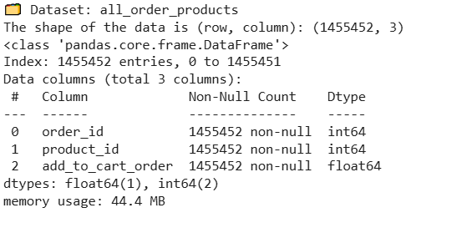

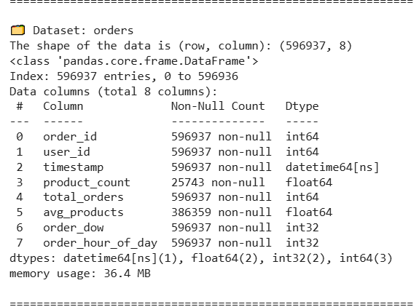

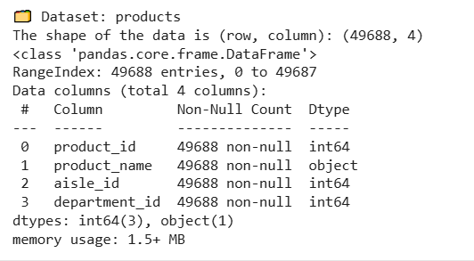



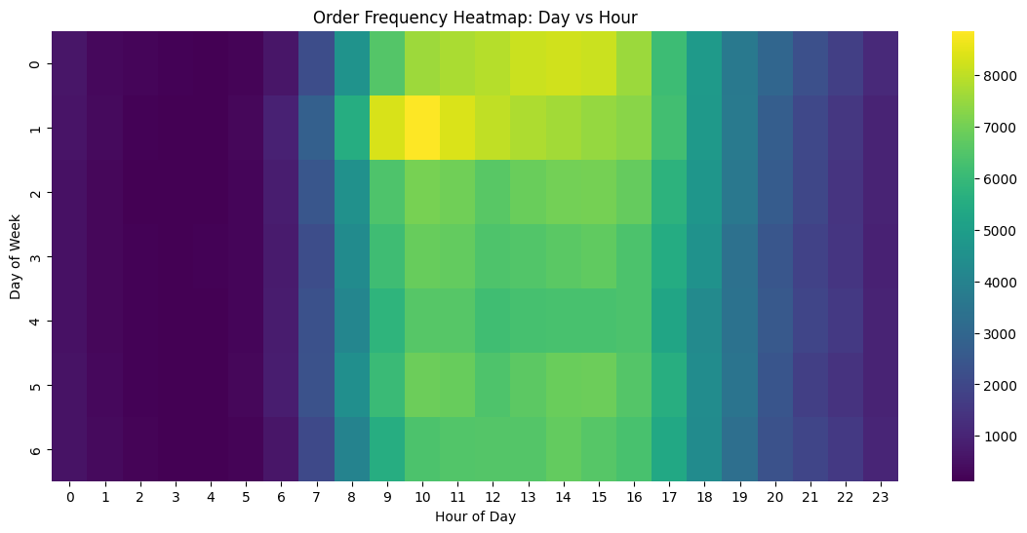

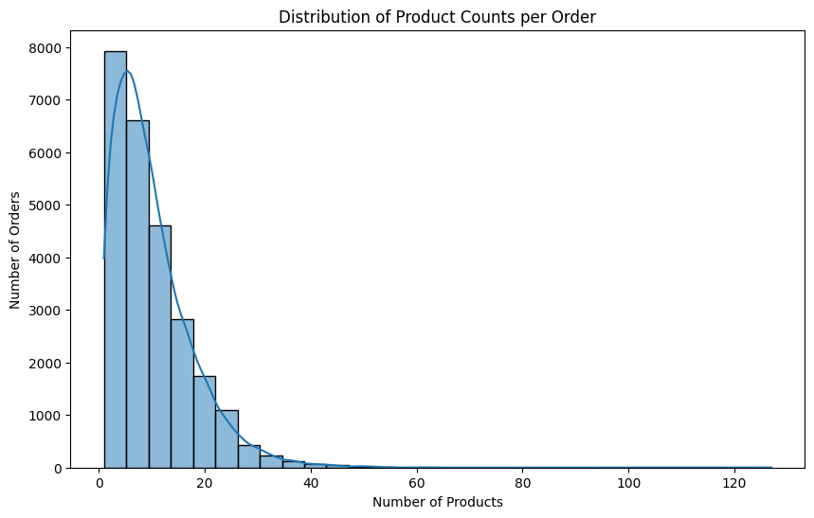

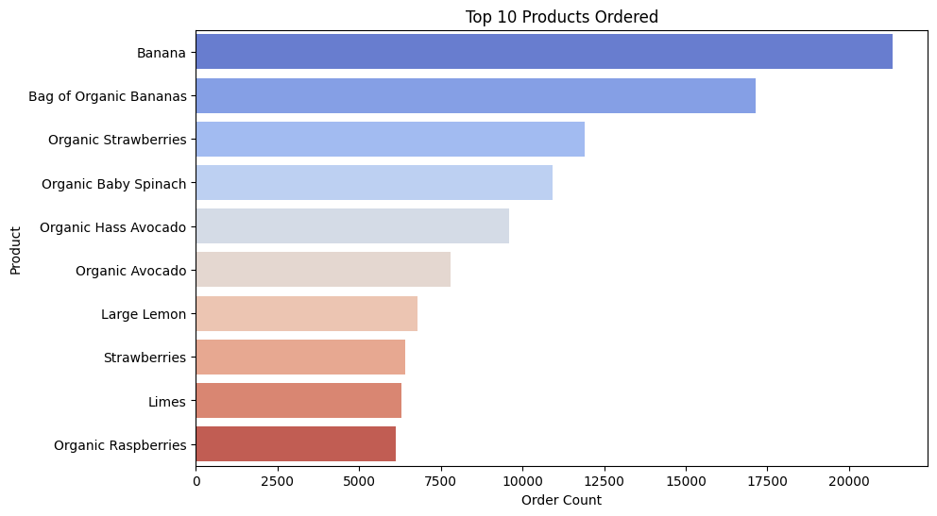

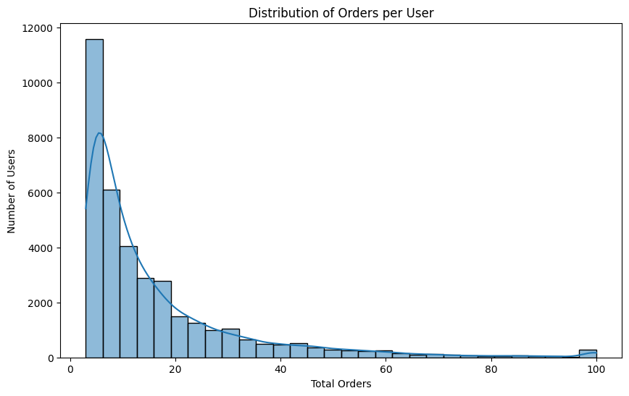

### LINKS:

* [**https://www.kaggle.com/datasets/brendanartley/simplifiedinstacartdata**](https://www.kaggle.com/datasets/brendanartley/simplifiedinstacartdata)
* [**https://github.com/bharathpk/Web-Blinders.git**](https://github.com/bharathpk/Web-Blinders.git)
* [**https://github.com/bharathpk/Spam-Detection.git**](https://github.com/bharathpk/Spam-Detection.git)